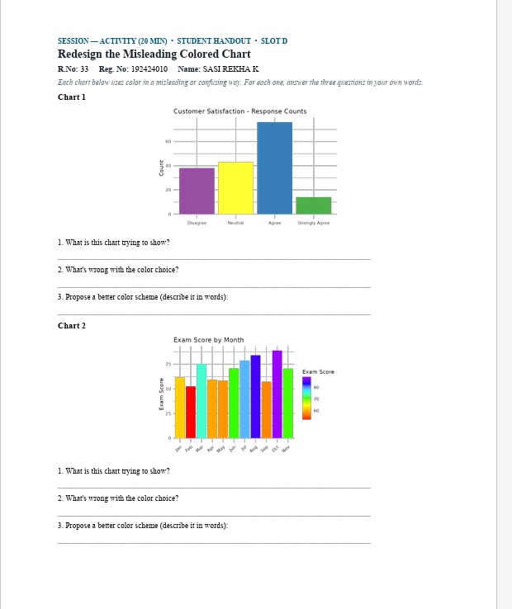

Chart 1
1. What is this chart trying to show?
It shows the number of responses for different customer satisfaction levels. “Agree” has the highest number of responses, while “Strongly Agree” has the lowest.
2. What’s wrong with the color choice?
The colors are very bright and different from each other. They do not clearly represent the order of satisfaction levels and may distract from the data.

3. Propose a better color scheme:
Use one color in different shades, from light to dark, for the satisfaction levels. For example: light blue for Disagree, medium blue for Neutral, darker blue for Agree, and darkest blue for Strongly Agree.

Chart 2
1. What is this chart trying to show?
It shows the exam scores for each month from January to December. It helps compare how the exam scores changed throughout the year.
2. What’s wrong with the color choice?
The chart uses many bright rainbow colors, which makes it difficult to focus on the scores. The colors do not have a clear meaning related to the months or scores.
3. Propose a better color scheme:
Use the same color for all months so that the focus remains on the scores. A slightly darker color can be used to highlight the highest score and a lighter shade for the lowest score.

